Employee(E)-Contactless Card

**By Group 4 :-**

**Abhi Shah (100902154)**

**Avinash Mishra (100897535)**

**Dheeraj Pagare (100856204)**

**Gagandeep Singh (100897670)**

**Kunwarpreet Singh Saggu (100880342)**

**April 18, 2023**

Contents

**Business Model: -**

**Overview:-**

With increasing concerns regarding the confidentiality of sensitive data, organizations are increasingly searching for remedies that safeguard their data and prevent it from being exposed to unauthorized access. Its primary goal is to enhance security, authenticity, and integrity by applying biometric authentication methods such as fingerprint and facial recognition. The E-contactless card utilizes algorithms for computer vision to guarantee that information is protected and that authorized individuals have access to it. Consequently, the solution assists in developing trust between the company and its stakeholders, such as employees, clients, and partners. Besides its security features, the E-contactless card offers a simple and efficient way for consumers to protect their data. The E-contactless card offers an extensive option for companies aiming for ways to enhance data security while preserving stakeholder trust.

**Problem Statement: -**

The problem statement is a result of the increasing threat of cyber attacks and data breaches that organizations worldwide face. With the growing dependence on digital technology, data is becoming increasingly valuable, and its protection is critical. Many organizations hold sensitive data, such as employee information, financial data, and intellectual property, which must be protected from unauthorized access, manipulation, and theft.

Based on the problem statement, enterprises throughout the world are dealing with the increasing challenge of maintaining sensitive data, in particular employee data, from unauthorized access, breaches of security, and cyber attacks. Existing evaluations of preventing data breaches and maintaining data integrity, which include passwords, PINs, and physical access controls, may not always be effective. As a consequence, businesses are looking for innovative and reliable systems that can give an increased degree of security, authenticity, and integrity.

Traditional methods of data protection, such as passwords and physical access controls, are not always effective, as they can be vulnerable to hacking, social engineering, and other forms of cyber attacks. Thus, organizations are seeking innovative solutions that provide higher levels of security, authenticity, and integrity for their sensitive data.

The E-contactless card assurances to solve this issue by deploying powerful biometric identification technology including fingerprint and facial recognition to verify individuals' identities and ensure confidential information access. Moreover, the solution involves computer vision algorithms which prevent acts of fraud while enhancing overall payment security. As an outcome, the E-contactless card will help organisations develop trust towards their stakeholders, including employees, clients, and partners.

The E-contactless card proposes to address this problem by leveraging advanced biometric authentication technologies such as fingerprint and facial recognition. This approach ensures that only authorized individuals can access the data, and it is impossible to replicate or fake the biometric data. In addition, the solution employs computer vision algorithms to detect and prevent fraudulent activities and enhance the overall security of the payment process.

**Problem Framework**  
The mind map depicts the various components of the E-contactless card security model, including the problem statement of organizations facing increased threats to the security of their sensitive data. The need for innovative and secure digital solutions is highlighted, and the proposed solution of biometric authentication and computer vision algorithms is shown.

The value proposition of enhanced security, authenticity, and integrity is emphasized, along with the target audience of organizations looking to protect their sensitive data. The mind map also depicts potential revenue streams, including licensing fees and consulting fees, as well as potential challenges, such as regulatory compliance and data privacy concerns.

**Problem Framework Mind Map**

Problem statement: organizations facing increased threats to the security of their sensitive data

Need for innovative and secure digital solutions

**Proposed solution**: biometric authentication and computer vision algorithms

**Value proposition**: enhanced security, authenticity, and integrity

**Target audience:** organizations looking to protect their sensitive data

**Potential revenue** streams: licensing fees and consulting fees

**Potential challenges**: regulatory compliance and data privacy concerns.

The value proposition of enhanced security, authenticity, and integrity is emphasized, along with the target audience of organizations looking to protect their sensitive data. The mind map also depicts potential revenue streams, including licensing fees and consulting fees, as well as potential challenges, such as regulatory compliance and data privacy concerns.

Overall, the problem framework mind map illustrates the various components of the E-contactless card security model, highlighting its value proposition, target audience, potential revenue streams, and potential challenges.

**Vision Statement:**

Our vision at E-contactless card is to become the leading provider of innovative and secure digital solutions that protect organizations' sensitive data from cyber attacks and data breaches. We envision a world where organizations can trust that their sensitive data is secure, and they can focus on achieving their business goals. Our vision is to provide a comprehensive and reliable security model that establishes trust between organizations and their stakeholders, including employees, clients, and partners. We aim to be the go-to solution for organizations that prioritize security and want to stay ahead of the ever-evolving threat landscape.

**Mission Statement:**

Our mission at E-contactless card is to develop a unique security model that leverages biometric authentication and computer vision algorithms to enhance the security, authenticity, and integrity of organizations' sensitive data. We understand the importance of data security and privacy for organizations of all sizes and industries, and we are committed to providing them with a secure and convenient solution that mitigates the risk of cyber attacks and data breaches. Our mission is to help organizations maintain compliance with regulatory requirements and protect their sensitive data from unauthorized access, disclosure, and alteration.

We are dedicated to delivering exceptional value to our customers by providing a reliable, easy-to-use, and scalable security model that enables them to focus on their business goals without worrying about the security of their sensitive data. We will achieve our mission by investing in the development of cutting-edge technology, collaborating with industry experts and thought leaders, and continuously improving our solutions to meet the evolving needs of our customers.

**Target Audience:**

Our target audience includes organizations that deal with sensitive data and want to mitigate the risk of cyber attacks and data breaches. This includes businesses in industries such as finance, healthcare, and government, as well as other organizations that deal with personal or confidential information. The needs of our target audience are to ensure the security, authenticity, and integrity of their sensitive data, maintain compliance with regulatory requirements, and establish trust with their stakeholders.

**Key Partners:**

Our key partners include biometric authentication technology providers, computer vision algorithm developers, cloud service providers, and regulatory compliance consultants. These partners help us to develop and implement our security model, maintain the accuracy and reliability of our technology, and ensure compliance with regulatory requirements.

**Value Proposition:**

Our value proposition is to provide organizations with a unique security model that leverages biometric authentication and computer vision algorithms to enhance the security, authenticity, and integrity of their sensitive data. Our solution is reliable, easy-to-use, and scalable, enabling organizations to mitigate the risk of cyber attacks and data breaches while maintaining compliance with regulatory requirements. By using our security model, organizations can establish trust with their stakeholders, increase their credibility and reputation, and focus on their core business operations.

**Cost Structure:**

Our cost structure includes expenses related to research and development, technology infrastructure, marketing and sales, and regulatory compliance. We also have operational expenses such as salaries, rent, and other overhead costs. Our cost structure is designed to ensure that we can deliver a high-quality and reliable security model to our customers while maintaining profitability.

Revenue Stream:

Our revenue stream is generated through licensing fees and consulting fees. Organizations can license our security model and implement it within their own infrastructure, or they can hire us to provide consulting services to develop and implement a customized security solution. Our revenue stream is designed to ensure that we can continue to invest in the development of our technology and provide exceptional value to our customers.

**Explanation of Value Creation:**

The E-contactless card security model meets the needs of our target audience by providing a reliable and secure solution that enhances the security, authenticity, and integrity of their sensitive data. By leveraging biometric authentication and computer vision algorithms, we are able to provide a unique security model that is more difficult to breach than traditional password-based systems. Our solution helps organizations to establish trust with their stakeholders, maintain compliance with regulatory requirements, and focus on their core business operations without worrying about the security of their sensitive data. By providing exceptional value to our customers, we are able to build long-term relationships and continue to grow our business.

The competitive landscape in the security industry is diverse, with many existing solutions available to organizations. However, our E-contactless card security model offers several unique features that differentiate it from existing solutions.

First, our security model leverages biometric authentication and computer vision algorithms to enhance the security, authenticity, and integrity of sensitive data. Traditional password-based systems are vulnerable to cyber attacks such as phishing, brute force attacks, and social engineering, whereas our solution is more secure and reliable due to the use of biometric authentication and computer vision algorithms.

Second, our solution is easy-to-use and scalable, enabling organizations to implement our security model without significant disruptions to their existing infrastructure. We offer a range of licensing and consulting services that can be customized to meet the specific needs of our customers, making it a flexible and adaptable solution.

Third, we prioritize regulatory compliance, ensuring that our security model meets industry standards and regulatory requirements. This is particularly important for organizations that deal with sensitive data in regulated industries such as healthcare and finance.

**Existing patent on similar technologies**

|  |  |  |  |
| --- | --- | --- | --- |
| **Name of the Existing Patent** | **Patent Number** | **Description** | **Remarks** |
| Secure contactless card emulation | US20170221047A1 | The data may be encrypted based on a dynamic diversified key associated with the dynamic card identifier. The device may perform the contactless transaction via the secure session based on exchanging the data to perform the mutual authentication to establish the secure session. | Our invention is unique. |
| Bank issued contactless payment card used in transit fare collection | US8688554B2 | The transit application specific data may include access control data (keys, passwords, identification data) or data required for fare calculations (rates, historical data on system use). | We are using IP Tag and coloring scheme to encrypt the data. Our invention is unique. |
| Contactless card reader and information processing system | US7845567B2 | The contactless card reader comprises a contactless card interface for communicating with a contactless card by means of radio frequency, a contact card interface coupled to said contactless card interface for communicating with a contact card | Existing invention using contactless card with using Radio Frequency but in our invention have different approach. |
| Clear contactless card | US20080203172A1 | The invisible optically recognizable compound is an infrared ink and/or film, which can be detected by a sensor found in an ATM or card assembly line. | Existing invention used RFID circuitry to encrypt the data. Our approach is different. |
| Method and system of offline contactless mobile payment based on magnetic near field communication | WO2016192562A9 | The method of offline contactless mobile payment based on mNFC comprises: feeding payment message, associated with bank card magnetic stripe information, as source data to a software based encoding unit. | Proposed storing and retrieving data in different manner. |

Data and technology risk assessment is a critical process that evaluates the potential risks associated with an organization's information systems and data. The goal of this assessment is to identify potential vulnerabilities and threats to the organization's data and technology infrastructure, and to implement appropriate measures to mitigate or eliminate these risks.

**Revenue Model:**

Our E-contactless card security model will be monetized through a subscription-based model. We will offer our services to organizations on a monthly or annual basis, depending on their needs and the scale of the project. Our pricing will be based on the size of the organization and the number of users that will be using our system. We will also offer different tiers of service, with higher tiers providing more features and functionality.

**Marketing Strategy:**

Our marketing strategy will focus on building brand awareness and trust among our target audience. We plan to use a combination of digital marketing tactics, including search engine optimization (SEO), pay-per-click (PPC) advertising, social media marketing, and content marketing. We will also leverage our network of key partners and industry experts to promote our services and build credibility in the industry.

**Financial Forecast:**

Our financial forecast for the first three years of operation is as follows:

Year 1:

Revenue: $500,000

Expenses: $300,000

Net Income: $200,000

We expect to achieve steady growth in revenue as we acquire more customers and expand our service offerings. We also anticipate increased expenses as we invest in marketing and product development. However, we believe that our strong revenue model and competitive advantage in the market will enable us to maintain a healthy net income and achieve long-term success.

**2. The technical details**

Our project is blending of machine learning, computer vision and cryptography. To develop our project, we followed several steps as below:

Prepared data for Employees:

* + - First, we synthesized employee data csv file by adding basic columns of employee such as ‘employee name’, ‘employee’, ‘gender’, ‘Mobile No’, ‘email’ and ‘Sin number’.
    - Second step is to take important details which can predict salary of employee based on ‘Job Title’, ‘Employee location’, ‘experience-level’, ‘employment type’, ‘remote ratio’, ‘Company size’. We took the data from Kaggle for above mentioned columns and link is as below:

https://www.kaggle.com/datasets/ruchi798/data- science-job-salaries

**Below is description of columns that we have in our dataset:**

|  |  |
| --- | --- |
| **Column Name** | **Description** |
| EmpId | Employee ID unique number |
| Name | Name of an employee |
| Gender | Gender of an employee Categorical value  As “Male” and “Female”. |
| Mobile No | Mobile No of an employee |
| Sin No | Sin No of an employee |
| work_year | The year the salary was paid. |
| experience_level | The experience level in the job during the year with the following possible values: EN Entry-level / Junior MI Mid-level / Intermediate SE Senior-level / Expert EX Executive-level / Director |
| employment_type | The type of employment for the role: PT Part-time FT Full-time CT Contract FL Freelance |
| job_title | The role worked in during the year |
| salary_in_usd | The salary in USD (FX rate divided by avg. USD rate for the respective year via fxdata.foorilla.com). |
| employee_residence | Employee's primary country of residence in during the work year as an ISO 3166 country code. |
| remote_ratio | The overall amount of work done remotely, possible values are as follows: 0 No remote work (less than 20%) 50 Partially remote 100 Fully remote (more than 80%) |
| company_location | The country of the employer's main office or contracting branch as an ISO 3166 country code. |
| company_size | The average number of people that worked for the company during the year: S less than 50 employees (small) M 50 to 250 employees (medium) L more than 250 employees. |

2) Our project secure the employee data using biometric data of their employee so data can only be retrieved if employee use fingerprint and face recognition (face recognition is currently not implemented). So data need to be stored in database.

3) There is a fingerprint column that is stored as byte array in table employee.

Here we choose PostgreSQL database to store employee details in database. Currently we have implemented data layer in python that will perform CRUD operations on PostgreSQL database.

Table schema for the project is as follows in screenshot:

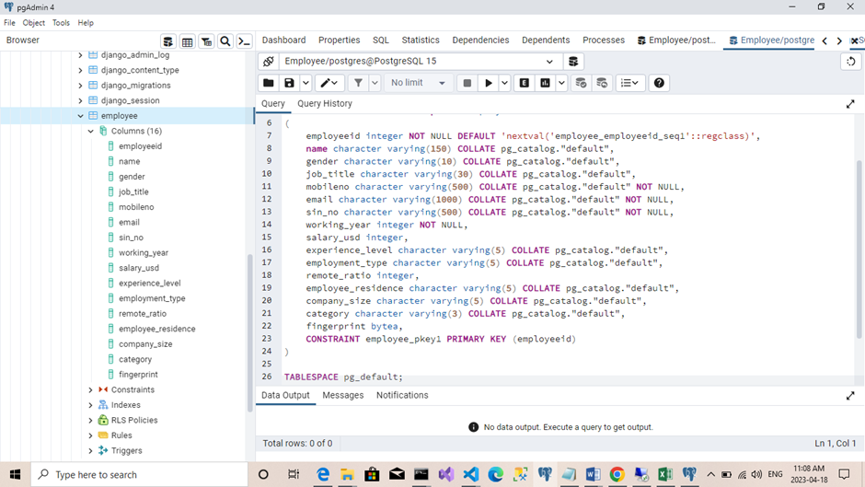

**Module 1: Employee Salary prediction:**

1. **First we loaded the dataset using pandas:**

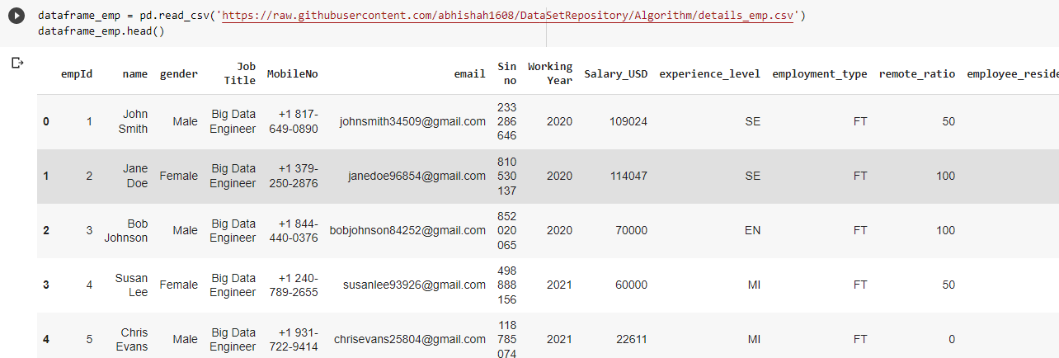

1. **Data pre-processing and Data cleaning:**

Here we already know that employee columns such as name, Employee Id, mobile No, sin no, email Address. So we dropped above mentioned columns.

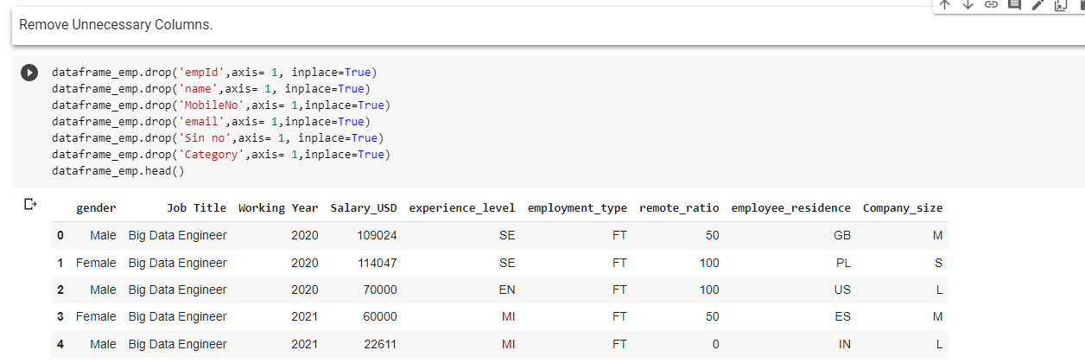

1. **There were categorical data found in following columns:**

'gender','Job Title','experience_level','employment_type','remote_ratio','employee_residence','Company_size'.

Used get_dummies to convert Categorical data to Numerical values.

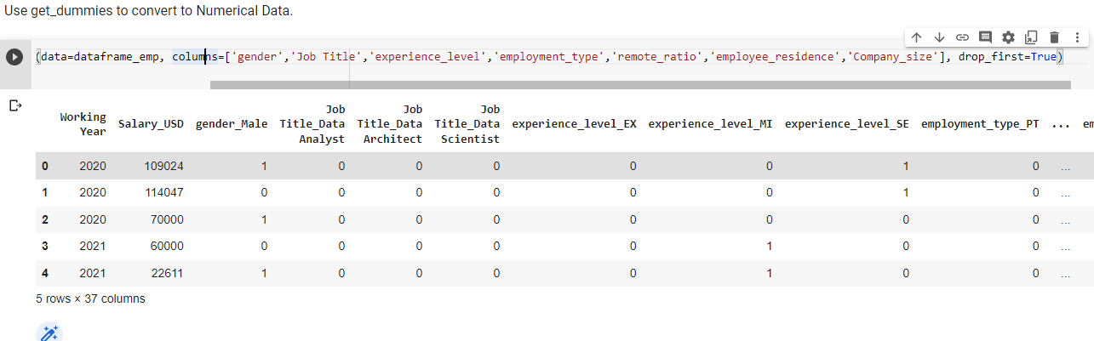

1. **Finding the Correlation with the target Column (Target column – Salary_USD).**

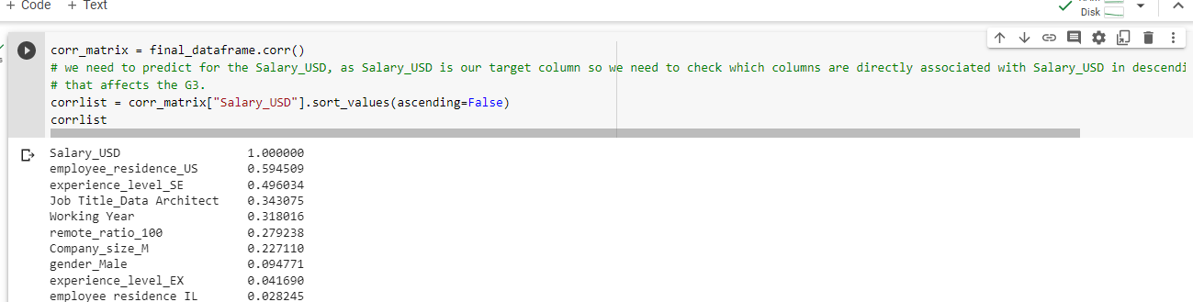

1. **Split the model into Train and test dataset.**

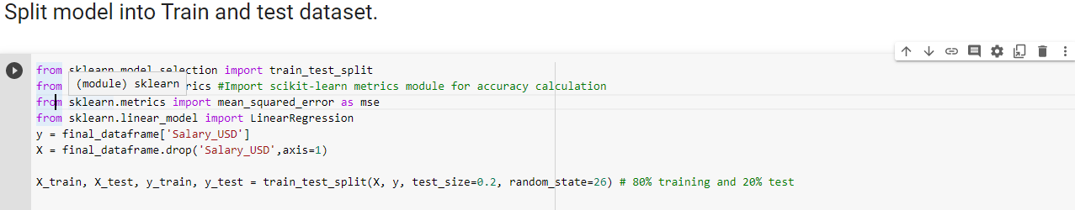

Now this Regression model as we are calculating the salary of an employee so we cannot use accuracy, we can use three parameter for the following,

1. MSE – (Mean square Error).
2. RMSE – (Root Mean Square Error)
3. MAE – (Mean Absolute Error).

But this problem is predicting salary in Dollars, so we might be using RMSE (Mean square Error would give large amount of data gap which will make the result incorrect and unpredictable).

We will use RMSE as a performance Parameter Matrix.

This is key Rule for the following:

Establish a baseline RMSE for your dataset using a naive predictive model, so that it can be used as a performance matrix such that those models having better RMSE than Naive predictive model are performing better models.

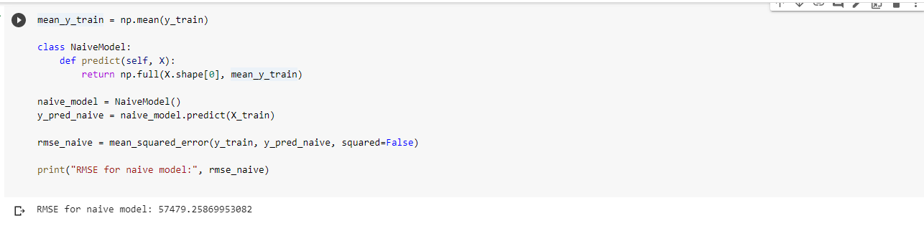

Implemented various model to measure the performance RMSE of the model to predict the salary of an employee.

|  |  |  |
| --- | --- | --- |
| Sr. No | Model Name | RMSE |
| 1 | NaïveModel – consider as a base model for performance matrices. | 57479.2586 |
| 2 | Linear Regression | 36868.0858 |
| 3 | DecisionTreeRegressor | 32909.8890 |
| 4 | Esembler learning for Voting Regressor.  LinearRegressor  RandomForestRegressor  KNN  XGBRegressor | 32358.3804 |

From the table, we can say that Ensemble learning for Voting Regressor performed well compared to other Models.

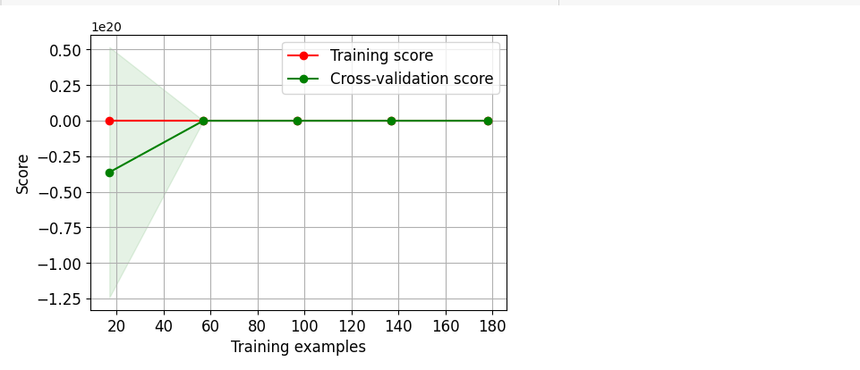

OpenCV library (Computer Vision) Used to match fingerprint of an employee using SIFT algorithm.

* SIFT **(Scale-Invariant Feature Transform)** is a computer vision method that is widely utilised for picture feature recognition and matching.
* David Lowe proposed it in 1999, and it has since become one of the most extensively used algorithms in computer vision and image processing. Fingerprint detection and matching is one major of its applications.
* The SIFT technique is used in fingerprint detection to find unique aspects in the fingerprint that may be used to compare it with other fingerprints.
* The method works by detecting keypoints, or points of interest, in the fingerprint image that are not affected by changes in scale, rotation, or lighting.
* Following that, these important points are defined using a feature vector that is resistant to noise and other image distortions.

**Screen shot of SIFT Algorithm implemented in project:**

import os

import cv2 as cv

test_img =cv.imread("C:\\Users\\Lenovo\\Desktop\\127.bmp")

filename = None

image = None

kp1, kp2, mp = None, None, None

best_score  = 0

for file in [file for file in os.listdir("C:\\Users\\Lenovo\Downloads\\db")]:

    file1 = "C:\\Users\\Lenovo\\Downloads\\db\\" + str(file)

    fingerprint_img = cv.imread(file1)

    sift = cv.SIFT_create()

    keypoints_1, descriptor_1 = sift.detectAndCompute(test_img, None)

    keypoints_2, descriptor_2 = sift.detectAndCompute(fingerprint_img, None)

    matches = cv.FlannBasedMatcher({'algorithm':1, 'trees': 10},{}).knnMatch(descriptor_1, descriptor_2, k = 2)

    match_points = []

    for p,q in matches:

        if p.distance < q.distance * 0.1:

            match_points.append(p)

    keypoints = 0

    if len(keypoints_1) < len(keypoints_2):

        keypoints = len(keypoints_1)

    else:

        keypoints = len(keypoints_2)

    if len(match_points) / keypoints * 100 > best_score:

        best_score = len(match_points) / keypoints * 100

        filename = file1

        image = fingerprint_img

        kp1, kp2, mp = keypoints_1, keypoints_2, matches

        print("Best match:" + filename)

        print("Best score:", best_score)

**Deploying the Model.**

We have followed several steps in order to deploy the model, entire application.

We will use Git as our code version control and we already deployed our code on GitHub.

For database progresSQL, we will use AWS cloud service (Amazon Relation Database service). We choose this as it is secured, scalable, high available.

For Rest API, we will use Amazon API Gateway – Manage, Monitor and publish API at any scale.

We will deploy Rest API, PostgreSQL, Frontend UI on AWS cloud.

**Ethical Considerations:**

Confidentiality: Organisations have a moral obligation to maintain employee data confidentiality. This means they must make certain that only authorised workers have access to the data while ensuring it is not shared with anyone who has not been granted permission to receive it.

Transparency: Companies must be open about the information they collect from their employees and how they use it. Employees should be educated about the data collected, how it is used, and who has access to it.

Informed consent: Before collecting and utilising employees' data, companies must obtain informed consent from them. Employees must be properly informed about the data being gathered, how it will be used, and who will have access to it. Employees should have the option to opt out of data collecting if they so desire.

Data Accuracy: Companies have an ethical responsibility to make sure that employee data is accurate and up to date. This means businesses must take steps to ensure the data they gather is trustworthy and that any inaccuracies are remedied as soon as possible.

Data security: Organisations have an ethical obligation to protect employee data. This means businesses must take the required safeguards to avoid unwanted data access as well as theft or loss.

Data retention: Companies should have policies in place that govern the retention of employee data. They must guarantee that data is not maintained for longer than necessary and that it is properly disposed of when no longer needed.

**Challenges:**

1. As predicting salary of an employee was difficult task, as MSE (mean square Error) error was showing very high. But we researched on our project and then we that found that best performance parameter was **‘RMSE’.**
2. Use of Encrypting and Decrypting second level encryption using color code based on Job title group was difficult and we tried to implement with failure.
3. Implementation of SIFT using OpenCV library for matching fingerprint.

**Test Plans:**

We will match fingerprint with group of fingerprint and then compare it with selected fingerprint to verify working functionality of SIFT algorithm.

Testing on Model performance by finding other employees job title, job location salary prediction based on model.

We have developed frontend UI to test employee insertion, update, deletion of employee detail.

**Version control software:**

As discussed before, we used private Git repository as a version control tool.

Git has many advantages:

1. Can create branch based on new feature.
2. Easy push and pull functionality on the Server.
3. Maintain code history.
4. Can easily integrate with CI/ CD pipelines such as docker, Jenkins.

**1. What is the project management philosophy used? (Eg: agile scrum)**

**Agile software development is a methodology that focuses on delivering software in small increments with regular feedback and collaboration between stakeholders and development teams. Agile emphasizes the importance of communication, flexibility, and adaptation to change, which can lead to better outcomes for software projects. Scrum, one of the most popular agile methodologies, emphasizes small team collaboration, regular meetings, and ceremonies to ensure progress is made.**

**One of the biggest benefits of agile and scrum is increased productivity. Agile encourages teams to break down projects into smaller tasks, which allows them to work on tasks in parallel, leading to faster delivery of working software. Additionally, the iterative nature of agile allows for quick feedback and improvement, leading to a more refined and higher-quality product. This approach also encourages stakeholders to get involved early and provide feedback regularly, which can reduce the number of bugs and defects in the final product, leading to fewer delays and higher customer satisfaction.**

**Agile's focus on collaboration and communication is also a significant advantage. The collaborative nature of agile and scrum allows teams to work together in a structured manner, with each member contributing their expertise and ideas. This approach ensures that everyone is working towards the same goal and allows for more open communication, leading to a more cohesive and productive team. Regular meetings, such as daily stand-ups, sprint planning, and retrospectives, provide an opportunity to discuss progress, identify issues, and adjust priorities.**

**However, agile and scrum also come with some challenges. One of the biggest challenges is the need for constant communication. Agile requires frequent meetings and collaboration between team members, stakeholders, and customers, which can be time-consuming and challenging to manage. Additionally, the iterative nature of agile and scrum means that priorities can change quickly, leading to confusion and disruption to the development process. This is especially true if the team is not prepared to handle these changes effectively.**

**Another challenge of agile and scrum is the need for a skilled and experienced team. Agile and scrum require a high level of collaboration and communication, which can be challenging if team members are not familiar with the methodology or lack the necessary skills. Additionally, agile and scrum require a certain level of discipline and structure, which can be difficult to maintain if team members are not committed to the process.**

**Agile and scrum are effective methodologies for software development. The focus on collaboration, flexibility, and communication can lead to higher productivity, improved quality, and greater customer satisfaction. However, the challenges of frequent communication and shifting priorities require a skilled and experienced team that is committed to the process. By embracing agile and scrum, teams can build better software faster, with greater accuracy, and more customer satisfaction.**

**2. Project team**

**The E-contactless Card project team is made up of five members, each with their specific roles and responsibilities. The team lead is Dheeraj Pagare, who will oversee the entire project's management, including coordinating team members' work and ensuring that deadlines are met. Dheeraj is also responsible for the user interface and user experience design and will make sure that the project aligns with the objectives set out by the stakeholders.**

**Abhi Shah is the AI architect, responsible for designing the overarching structure and architecture of the artificial intelligence algorithms that will be used in the E-contactless Card project. Abhi will make sure that the AI models are effective, scalable, align and well trained with the project's objectives as well as helped in the fetching the finger print data.**

**Avinash Mishra is the AI programmer/developer, tasked with building the code to implement the AI models created by the AI architect. Avinash's primary responsibility is to make sure that the code is of exceptional quality and follows the project's requirements. One of the main task was to connect the UxUi data and apply the encrypt algorithm and decrypt the data and feed back to the UxUi page.**

**Kunwarpreet Singh Saggu is the DevOps engineer, responsible for ensuring that the software development and deployment process runs smoothly. This includes deploying and maintaining the project in a reliable and secure way, as well as developing and maintaining the development and testing environments. As per project requirement uploaded project to GitHub as this will be accessible to all and anyone can help if one got stuck anywher**

**Finally, Gagandeep Singh is the data analyst, responsible for examining the information produced by the AI models and suggesting improvements. Gagandeep will make sure that the data used to train the AI models are of high quality and align with the project's specifications.**

**To ensure effective communication within the team, regular team meetings were held, with 2-3 stand-up meetings each week. These meetings helped us to ensure that everyone is aware of the project's progress and that any issues can be quickly identified and addressed.**

**The team's workflow followed the Agile Scrum methodology, which emphasizes iterative and incremental development. As per project demands we also broke down the main parts like encryption and model selecting into sub-teams by pairing with 2 or more people so that individual won’t face any alone burden. Short, time-boxed sprints were used to break down the project into manageable chunks, with regular feedback meetings held to ensure the project is moving forward smoothly and accomplishing its objectives.**

**The Agile Scrum methodology also facilitates the team's ability to adapt to changes in project requirements or scope. Agile Scrum emphasizes flexibility and the ability to adapt to changing needs, which will be essential for our project.**

**The team's communication channels were open and transparent, allowing for quick and effective communication. Team members used tools like Slack and email to keep in touch and collaborate, and regular progress reports will be provided to stakeholders to keep them up to date on the project's status.**

**3. Project Timeline**

**The project's timeline spans 5 weeks, beginning on the week of March 12th and ending on the week of April 12th.**

**During the first week, the project team's primary focus was on setting up the project's tools and infrastructure. The team assigned roles, discussed the project's modules and requirements, and created a GitHub repository to store and manage the project's codebase. The team also began synthesizing the dataset and added details to the database from CSV. Additionally, the team used Figma to design the project's UI/UX.**

**In the second week, the team identified issues while implementing employee salary prediction and using the SIFT algorithm to detect fingerprint matching of employees. The team worked together to address these issues and discussed creating a presentation and its contents. The team also developed a flowchart to be followed during the presentation. By the end of the week, the team had resolved the identified issues and drew conclusions.**

**During the third week, the team focused on the process of ciphering plain text and discussed various encryption models through online mediums. The team also developed the past.py file to compare the actual fingerprint width to test fingerprints to match using IFT. The team worked together to identify the most effective encryption algorithm to use in the project.**

**In the fourth week, the team looked for an encryption algorithm to cipher the text and implemented a non-linear regression model for salary prediction. The team also dug into information about various encryption algorithms to determine the most appropriate for the project's needs.**

**During the final week, specific actions were taken to complete the project. Avinash decrypted the data, and Abhi helped with salary prediction. Gagan helped Kunwarpreet with their report and presentation. Dheeraj communicated with team members and solved UI form errors, while Kunwarpreet gathered information about different algorithms and looked for deployment strategies.**

**The project timeline includes start and end dates for each task and identifies any dependencies or critical paths that could impact the project's timeline. This helps the project team to stay on track, meet the project's objectives, and complete the project within the allotted time frame. By following the timeline, the team can ensure that each task is completed in a timely manner and that any dependencies are addressed to avoid potential delays. The timeline provides a clear roadmap for the project's completion and ensures that the team stays organized and focused throughout the project's lifecycle.**

**4. Communication and reporting**

**Effective communication is key to the success of any project, and our team made it a priority to establish a robust communication plan from the outset. We recognized the importance of keeping all team members and stakeholders informed of our progress, addressing issues quickly, and ensuring that everyone had the information they needed to perform their roles effectively. Even on the weekly bases we have made reports which we can even visualize and make it into Ghant Charts which can help stakeholders or customers as well as to the team to have a clear and correct path where to move.**

**To facilitate communication within the team, we held weekly meetings where we discussed progress, identified issues, and planned the next steps. These meetings were crucial in ensuring that everyone was aware of the progress being made and any issues that needed to be addressed. By discussing our progress regularly, we were able to quickly identify areas that needed more attention and ensure that everyone was on the same page.**

**In addition to our weekly meetings, we also made use of various communication channels to stay in touch. We used email, WhatsApp, and Microsoft Teams to communicate throughout the week, sharing files and discussing any issues that arose. We also used online collaboration tools such as Google Drive and GitHub to work on code collaboratively, ensuring that everyone had access to the latest version of the codebase.**

**Reporting was an essential part of our communication plan, and we agreed to provide weekly progress reports to our professor. These reports included a summary of the work we had completed during the week, any issues we encountered, and our plan for the next week. This regular reporting helped us stay accountable and ensured that our professor was aware of our progress. And help us to know about what’s our actual target for this and how to split down the milestones so that we can move forward with each week. We let milestone as it helps to motivate an individual or we can say self-motivation to stick to it till it’s completed.**

**For stakeholders outside of our team, we planned to provide regular updates via email and in-person meetings as needed. We recognized that stakeholders would need to be kept informed of our progress, and we made it a priority to communicate with them regularly. Even we will schedule the regular bases call with them as the words have more impact and by this we can know more if there is anything else the stakeholder wants. We also created a presentation that summarized our project, which we could use to provide a high-level overview of our progress and outcomes. This presentation was an effective tool for communicating our progress to stakeholders who may not have been as familiar with the technical details of the project.**

**Overall, our communication plan was effective in keeping everyone informed and ensuring that progress was reported regularly. By establishing open lines of communication and keeping everyone informed, we were able to address issues quickly and ensure that everyone was working towards the same goals. Our communication plan was an essential part of the project's success and helped us deliver a high-quality product on time.**

**5. Budget and resources**

**The budget and resources required to complete a project are crucial components that need to be well-planned and executed to ensure that the project's goals are achieved successfully. In this section, we will describe in detail the E-contactless Card project's budget and resources used to complete the project.**

**The total budget allocated for the E-contactless Card project was $50,000. The budget was allocated to cover the expenses for labor, materials, and equipment required to complete the project successfully. The breakdown of the project costs is as follows:**

**Labor Costs:**

**The labor costs for the project included the salaries of the project team members, who were working on the project on a full-time basis. The project team consisted of six members, including a team lead, UI/UX designer, AI architect, AI programmer/developer, DevOps engineer, and data analyst. The team lead was responsible for managing the project's overall progress and ensuring that the project's goals were met within the allocated budget and timeframe. The UI/UX designer was responsible for designing the user interface and user experience of the E-contactless Card application. The AI architect was responsible for designing the AI model architecture and algorithm that would be used to recognize and authenticate the users' biometric data. The AI programmer/developer was responsible for developing the AI model using Python programming language and various libraries and frameworks required for AI development. The DevOps engineer was responsible for managing the servers and deploying the application to production. The data analyst was responsible for analyzing the user data and generating insights that would help improve the application's performance. The team members were paid based on the number of hours they worked and the tasks they completed. The labor costs accounted for 60% of the total project budget, which is $30,000.**

**Materials:**

**The materials used in the project include the software and hardware tools required for development and testing. The team required high-end computers and servers to perform the AI model training and testing. The software tools used in the project include Figma for UI/UX design, GitHub for version control, Python programming language for AI model development, and various other libraries and frameworks required for AI development. The material costs accounted for 30% of the total project budget, which is $15,000.**

**Equipment:**

**The equipment required for the project includes computers, servers, and other hardware peripherals. The team required high-end computers and servers for AI model training and testing. The equipment costs accounted for 10% of the total project budget, which is $5,000.**

**Risks and Contingencies:**

**There were several risks associated with the project that could have impacted the project's budget. One of the significant risks was the availability of the required resources. In case the team members were not available due to unforeseen circumstances, the project's progress could be delayed, leading to additional labor costs. Another risk was the availability of the hardware and software tools required for development and testing. The project team had to ensure that the required resources were always available to avoid delays in the project's progress. To mitigate these risks, the project team kept a contingency fund of $5,000, which was allocated for unforeseen expenses that might arise during the project.**

**In conclusion, the E-contactless Card project's budget and resources were well-planned and executed to ensure that the project's goals were achieved successfully. The project team was able to complete the project within the allocated budget of $50,000, and the project team was able to deliver a high-quality product that met the client's expectations. The project's success can be attributed to the effective allocation of resources, regular monitoring of progress, and timely identification and mitigation of risks.**

**Visuals :-**

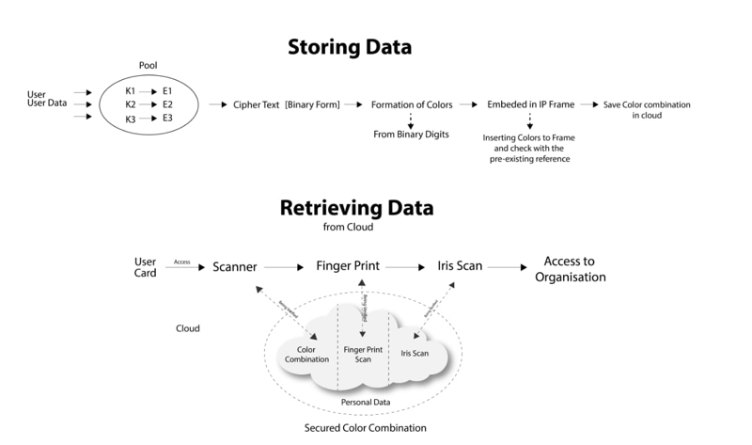

**Employee save flow (Encryption flow)**

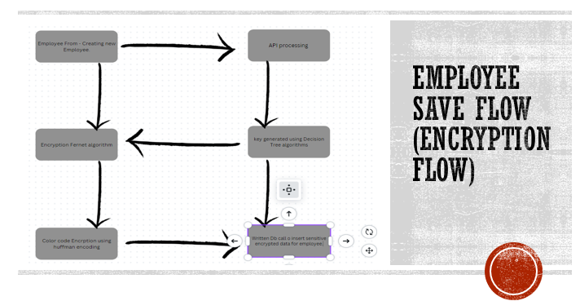

**Employee retrieval (Decryption flow).**

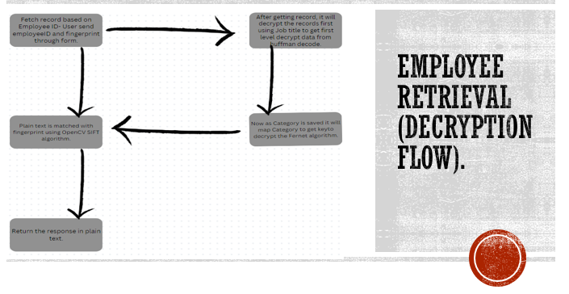

**Encryption and Decryption**

**UXUI Form for filling the Data**



**After Filling the form**

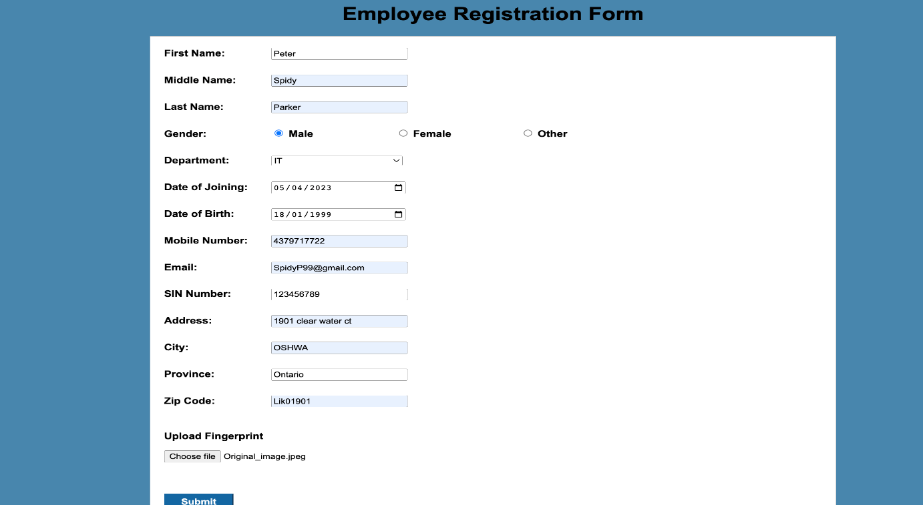

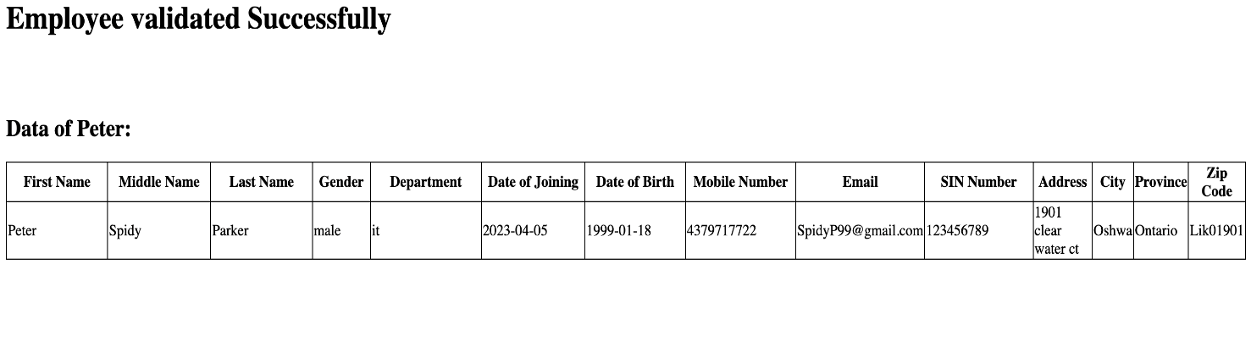

**Encrypted Data: -**

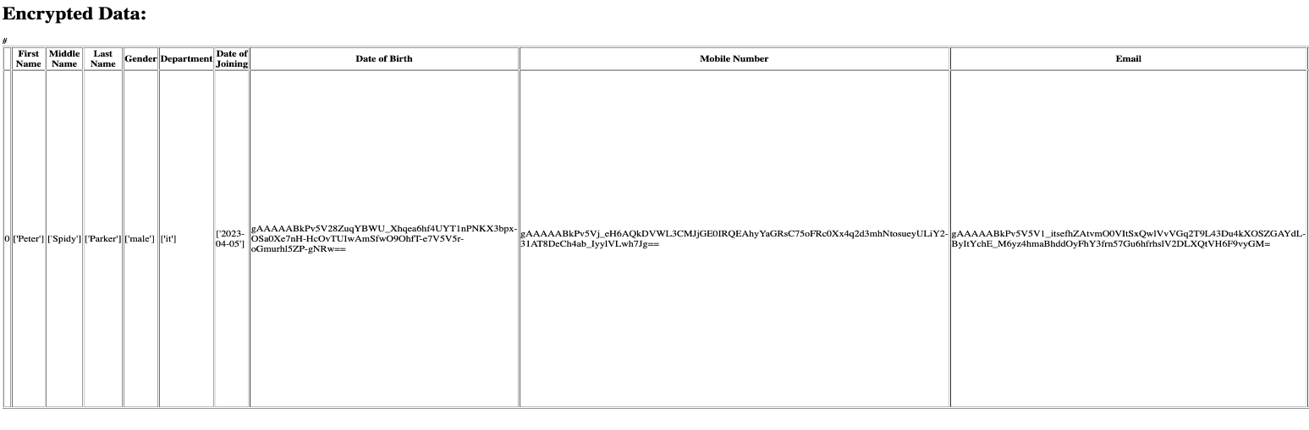

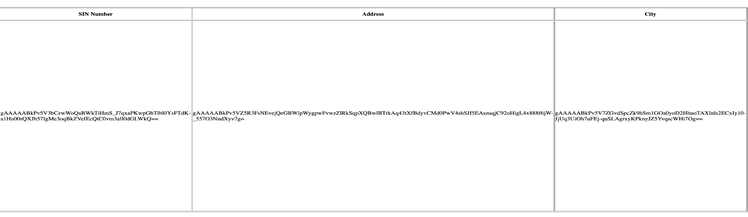

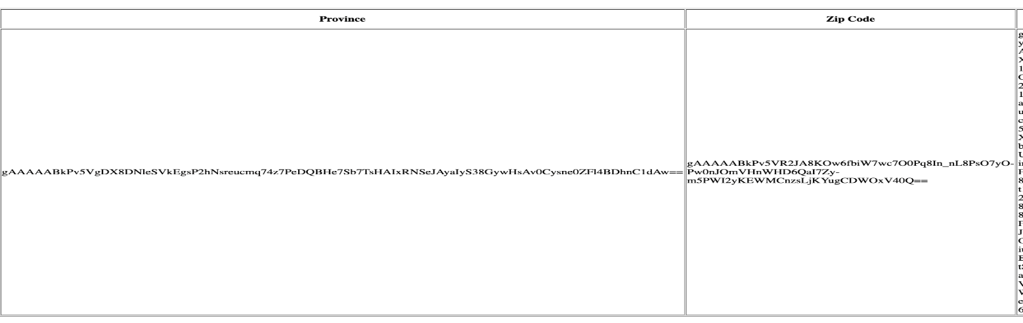

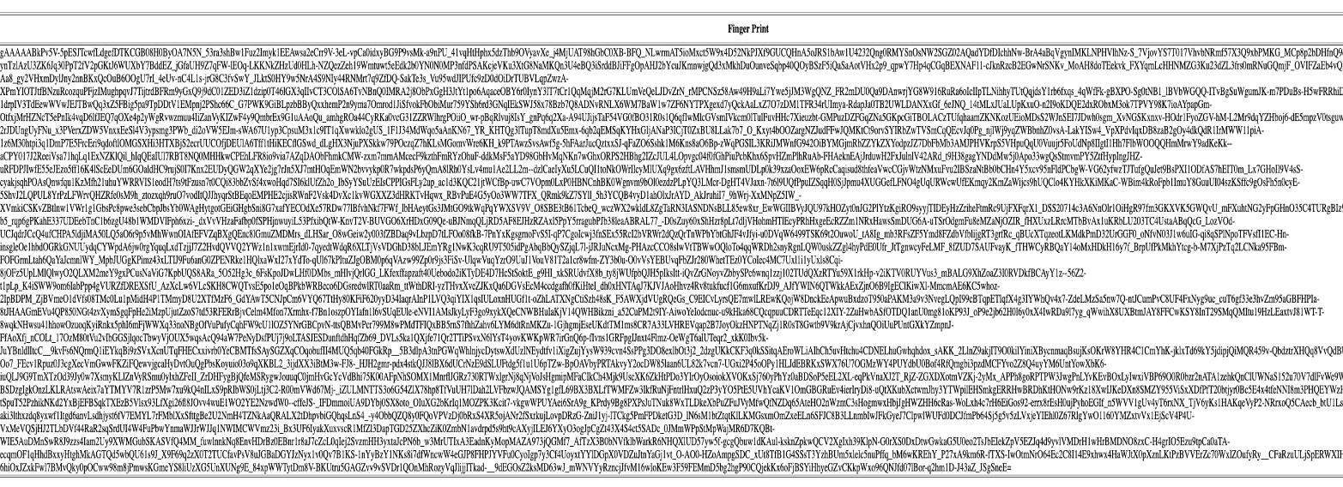

**Encrypted Code:-**

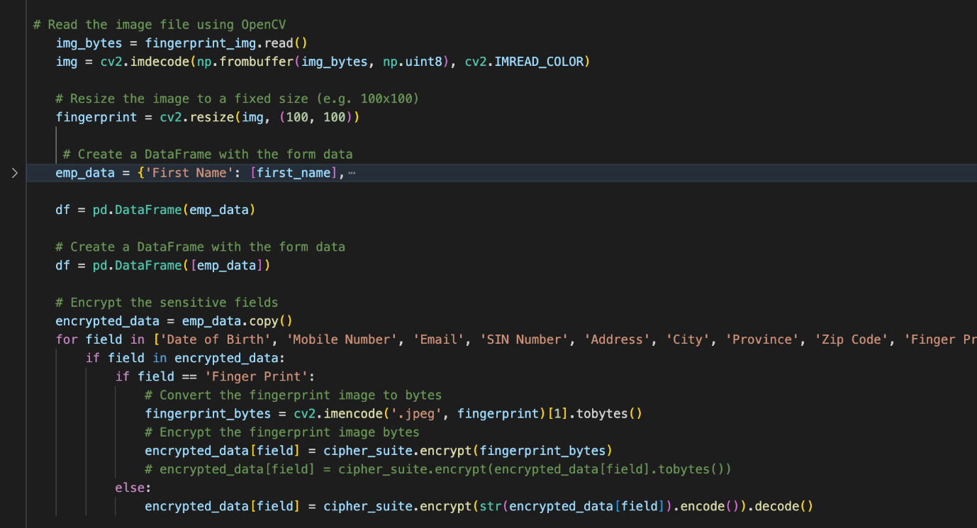

**Decrypted Code**

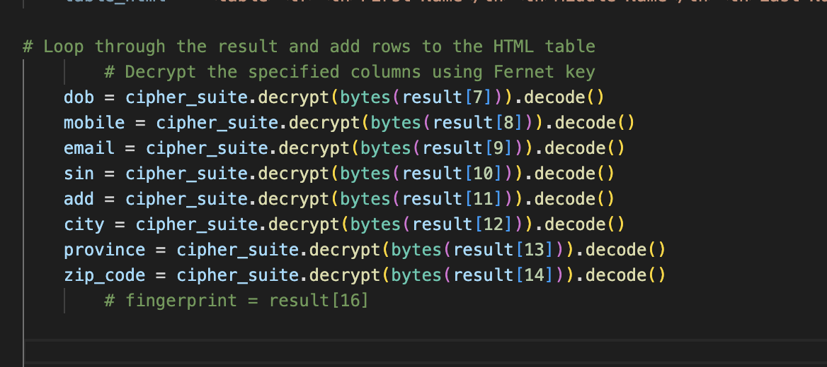

**References:**

<https://machinelearningmastery.com/regression-metrics-for-machine-learning/>

<https://en.wikipedia.org/wiki/Scale-invariant_feature_transform>

<https://www.youtube.com/watch?v=IIvfqfKkiio>

<https://coderzcolumn.com/tutorials/machine-learning/scikit-plot-visualizing-machine-learning-algorithm-results-and-performance>

<https://aws.amazon.com/rds/postgresql/>

<https://aws.amazon.com/api-gateway/>